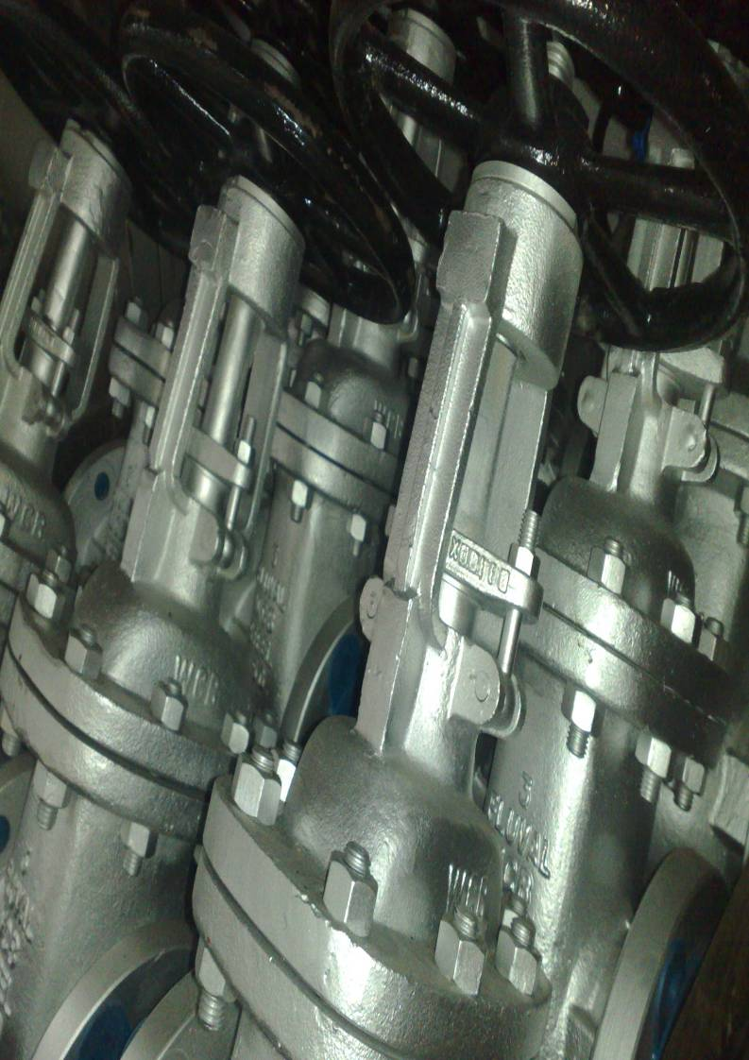



Suppliers to the worlds
Oil and Petrochemical
Industries



Global Oilfield Supplies is a leading supplier to the Oil and Petrochemical Industries worldwide, supplying urgent requirements from stock, or lead time projects worldwide.

Our status and reputation has been built from over 20 years of experience in supplying Valves, Gaskets and Ancillary Pipeline Equipment to end users and traders worldwide.

The objectives of our Company are to maintain and improve market leadership by ensuring that high standards of Service, Product Quality and Quality Assurance are employed to meet the requirements of client specification and National & International Standards. By constant monitoring of Non-Conformances, Customer Complaints and Customer Satisfaction, we aim to continuously improve the service given by the Company. Each business year shall be conducted to work towards reducing Customer Complaints and Non-Conformances.

In order to achieve this policy, the Company has documented its method of operation in the form of a Quality System compatible with the requirements of BS EN ISO 9001 : 2000 and incorporating the requirements of the Pressure Equipment Directive & ATEX Directives

Each Global Oilfield Supplies member of staff is made aware of this Commitment to this policy and is required to fully participate in applying and improving the Company’s Quality System.

Training and education, where appropriate, will be used to ensure that personnel are fully conversant with the Company’s objectives on an on-going basis.

In achieving these objectives Global Oilfield Supplies will also maintain it’s commercial profitability, which is the foremost objective of any organisation, without which, further enhancement cannot be accomplished.

---------------------------------
Paul Dargan
Managing Director

Supply Scope

We are happy to provide your company with the following products:-

Valves

Gate, Globe, Piston Check, Ball Check and Swing Check
½” to 2” - Design BS5352 / API 602 – Class 150# to 4500#
NPT, Socket Weld, Butt Weld, Flanged RF/RTJ
Materials : A105N, LF2, F316L - Trims : 8, 5, 10, 12 and 16

Gate, Globe and Swing Check
2” to 48” – Design API 600, API 6D, BS1414, BS1873, BS1868
Class 150# - 4500# - Butt Weld, Flanged RF/RTJ
Materials : WCB, LCC, CF8M – Trims : 8, 5, 10, 12 and 16

Floating Ball Valves
½” to 12” – Design BS5351, BS6755 – Full & Reduced Bore
Class 150# to 1500# - NPT, Socket Weld, Butt-Weld, Flanged RF/RTJ
Materials : A105N/WCB, LF2/LCC, F316/CF8M, PTFE/RTPFE/Nylon

Trunnion Mounted Ball Valves
2” to 36” – Design API 6D, API 607 – Full & Reduced Bore
Class 150# to 2500# - Butt Weld, Flanged RF/RTJ
Materials : A105N/WCB, LF2/LCC, F316/CF8M, PTFE/RPTFE/Nylon

Specials :
Monel, Hastelloy, Duplex, Super Duplex, Titanium Body and/or Trims
Lagging Extensions, Cryogenic Extensions, Soft Inserts, NDE, Locking Device, Painting

Gaskets

Metallic Gaskets
Ring Type Joints – Materials Soft Iron, SS304, SS316, SS321, SS347, Exotics
Spiral Wound Gasket – Stainless Steel or Exotic Windings, Graphite or PTFE Filler

Soft Cut Gaskets
Non-Asbestos, Graphite, Rubber, PTFE

Gasket Sheeting Materials
1000mm to 2000mm sheet sizes
Non Asbestos, Graphite, Rubber, PTFE

Pipeline Equipment

Pipe
Flanges
Fittings
Bolting



Gate Valve

Gate Valves are Bi-Directional and mainly used for On/Off operation with low pressure drop. A rising stem provides position indication.
The solid or flexible wedge will seal against metal seats with acceptable leakage rates per API 598.
When fully open, the typical gate valve has no obstruction in the flow path, resulting in very low friction loss.

Forged Steel - Available in sizes ¼” to 2” in ANSI Classes 150LB to 4500LB.
Designed per EN ISO 15761, BS5352, API 602 and ASME B16.34
Ends Connections NPTF, SW, BW, RF and RTJ
A105N, LF2, F1, F5, F9, F11, F22, F304(L), F316(L), F321, F347

Cast Steel - Available in sizes 2” to 72” in ANSI Classes 150LB to 2500LB
Designed per API 600, BS1414 and ASME B16.34
End Connections RF, RTJ or BW
WCB, LCC, CF3(M), CF8(M), WC1, WC6, C5, C12, CF8C, CN7M

Special materials also available : Duplex, Super Duplex, Monel, Hastelloy, Titanium, Inconel, Incoloy, 6MO

Modifications include Actuation, Stem / Cryogenic Extensions, Pipe Pups & Soft Inserts

Globe Valve

Globe Valves are Uni-Directional and are designed for regulation / control of flow, also known as throttling.
Various disc designs are available. The standard is a Plug or Ball type but for varying control of regulation Needle, Parabolic and Vee-Reg are also available.
Globe Valves are also metal seated as standard with acceptable leakage rates per API 598.

Forged Steel - Available in sizes ¼” to 2” in ANSI Classes 150LB to 4500LB.
Designed per EN ISO 15761, BS5352, API 602 and ASME B16.34
Ends Connections NPTF, SW, BW, RF and RTJ
A105N, LF2, F1, F5, F9, F11, F22, F304(L), F316(L), F321, F347

Cast Steel - Available in sizes 2” to 24” in ANSI Classes 150LB to 2500LB
Designed per API 600, BS1873 and ASME B16.34
End Connections RF, RTJ or BW
WCB, LCC, CF3(M), CF8(M), WC1, WC6, C5, C12, CF8C, CN7M

Special materials also available : Duplex, Super Duplex, Monel, Hastelloy, Titanium, Inconel, Incoloy, 6MO

Modifications include Actuation, Stem / Cryogenic Extensions, Pipe Pups & Soft Inserts

Check Valve

Check valves, or Non-Return Valves, are also Uni-Directional and designed to stop backflow in the system. Check Valves operate automatically by reaction to the fluid.
There are various types of Check Valves in our ANSI range.

Piston or Ball Check Valves are normally spring assisted to force the Piston/Ball onto the seat for a better seal. A low maintenance option with metal seats to limit the amount of wear.

Swing Checks become more standard for sizes 2” and upwards where the valve bore is full and a Piston or Ball would become too heavy for the fluid to lift.
Due to the disc’s resistance against flow, there is a relatively large pressure drop.

Wafer Check Valves are also available, per API 594 design, to fit between flanges. Smaller in design and therefore cost effective the Wafer Check is available with Metal or Soft Seats.

Forged Steel - Available in sizes ½” to 2” in ANSI Classes 150LB to 4500LB
Designed per EN ISO 15761, BS5352, API 602 and ASME B16.34
Ends Connections NPTF, SW, BW, RF and RTJ
A105N, LF2, F1, F5, F9, F11, F22, F304 (L), F316 (L), F321, F347

Cast Steel - Available in sizes 2” to 36” in ANSI Classes 150LB to 2500LB
Designed per API 600, BS1868, API 594 and ASME B16.34
End Connections RF, RTJ or BW
Wafer Type in Dual Plate, Lugged, Double Flanged
WCB, LCC, CF3 (M), CF8(M), WC1, WC6, C5, C12, CF8C, CN7M

Special materials also available : Duplex, Super Duplex, Monel, Hastelloy, Titanium, Inconel, Incoloy, 6MO

Modifications include Actuation, Stem / Cryogenic Extensions, Pipe Pups & Soft Inserts

Ball Valve

Ball Valves Bi-Directional and used for On/Off Operation, without pressure drop, where zero leakage is a must. Lever Operators will show the position of the Ball and these Valves are available in Full Bore or Reduced Bore across all sizes from ½”.
Ball Valves are generally firesafe to avoid damage to soft seats and for safe use on gas applications.
Ball Valves come in Floating Ball or Trunnion Mounted design

Floating Ball Design

The soft seats hold the Ball in place and when closed the flow will press the Ball into the soft seats for a zero leakage seal.

Available in sizes ½” to 12” in ANSI Class 150LB to 1500LB
Designed per BS5351 and firesafe to API 607, API 6FA or BS6755 Pt2
Ends Connections NPTF, SW, BW, RF or RTJ
Materials WCB, LCC, CF3 (M), CF8 (M), CF8C, CN7M.
Trims in Stainless Steel, ENP, 17.4PH with Seats PTFE, RPTFE, Nylon, Viton or PEEK

Special materials also available : Duplex, Super Duplex, Monel, Hastelloy, Titanium, Inconel, Incoloy, 6MO

Modifications include Gearboxes, Actuation, Stem / Cryogenic Extensions & Pipe Pups

Trunnion Mounted Design

For larger sizes / higher pressure applications a Trunnion Mounted design is standard. The seats are spring energized for double block & bleed design.
By supporting the Ball on a Trunnion, the operating torque can be reduced to approximately two-thirds of a floating Ball.

Available in sizes 2” to 36” in ANSI Classes 150LB to 4500LB
Designed per API 6D and firesafe to API 607, API 6FA and BS6755 Pt2
Ends Connections BW, RF or RTJ
A105N, LF2, F304(L), F316(L), F321, F347
WCB, LCC, CF3(M), CF8(M), CF8C, CN7M
Trims in Stainless Steel, ENP, 17.4PH with Seats PTFE, RPTFE, Nylon, Viton or PEEK

Special materials also available : Duplex, Super Duplex, Monel, Hastelloy, Titanium, Inconel, Incoloy, 6MO

Modifications include Actuation, Stem / Cryogenic Extensions & Pipe Pups

Butterfly Valve

Butterfly Valves are quarter-turn valves and can be used where space is limited. Wafer Pattern Butterfly Valves are designed to fit between flanges.
Operation by lever can show the disc position, which when fully open offers limited resistance to the flow. Gear Operators are used for larger sizes.
Resilient type will have soft seats, high performance is usually double eccentric and tricentric are usually with metal seats.
The varying designs allow for tight shut-off or throttling service.

Available in sizes 2” to 36” in ANSI Class 150LB to 2500LB
Designed to API 609, BS 5155, MSS-SP-67 and firesafe to API 607 where applicable
Designed to suit either RF or RTJ Flanges
Materials WCB, LCB, CF8, CF8M
Trims in Stainless Steel, 17.4PH with Seats PTFE, RPTFE, Metal or Rubber

Special materials also available : Duplex, Super Duplex, Monel, Hastelloy, Titanium, Inconel, Incoloy, 6MO

Modifications include Actuation and Stem Extensions.

Modification

All types of modification are offered by Global Oilfield Supplies on our valve range including cryogenic extensions for low temperature operation, standard stem extensions (supported and unsupported) for lagging clearance purposes. We are able to offer a full range of trim conversions to suit specific service conditions and media, these conversions can also include gland packing changes, gasket changes, soft inserts and bolt changes.

Other modifications available :
Drilled and tapped plugs, bleeds and drains.
Actuation (Pneumatic and Electric) fitted and tested.
Limit switches
Locking devices
Position indicators
Pipe pups (including PWHT when relevant)
Gear box conversions
Spring return levers

Please call our sales team to discuss your requirements.

Spiral Wound Gaskets

GOS Spiral wound gaskets are made of a preformed metallic strip and a soft filler material (PTFE or Flexible graphite), wound together under pressure, and optionally with an inner and/or outer guide ring. The metal strip holds the filler, resulting in excellent mechanical resistance, resilience and recovery.

The four most basic styles listed as follows:

Type S
Basic construction type, wound by steel tape and filler material. Suitable for tongue and groove or male and female or grooved to flat face flange assemblies.

Type S-IR
Solid inner metal ring acts as a compression stop and fills the annular space between flange bore and the inside diameter. Designed to prevent accumulation of solids, reduce turbulent flow of process fluids and minimise erosion of flange faces. Suitable for male and female pipe flange.

Type GS
Utilises an external ring which accurately centres gasket on flange face, providing additional strength to prevent gasket blow-out and acts as a compression stop. A general purpose gasket suitable for use with flat face and raised face flanges. Advantages of having an inner ring as mentioned for type S-IR.

Type GS-IR
Utilises an external ring which accurately centres gasket on flange face, providing additional strength to prevent gasket blow-out and acts as a compression stop. A general purpose gasket suitable for use with flat face and raised face flanges. Advantages of having an inner ring as mentioned for type S-IR.

Ring Joint Gaskets

GOS "RTJ" (Ring Type Joint) gaskets are manufactured in accordance with API-6A and ANSI B16.2 specifications.

API ring joints come in two basic types, oval and an octagonal shape. These basic shapes are used in pressures up to 10,000 psi. The dimensions are standardised and require specially grooved flanges. The octagonal cross section has a higher sealing efficiency than the oval and would be the preferred gasket.

RTJ's have "R" numbers assigned to them for pipe size and pressure class identification. Stock materials include soft iron, low carbon steel, 4-6 chrome (F5), 304, 304L, 316, 316L, 347, Monel, Inconel and Incoloy.

Camprofile Gaskets

GOS Camprofile gaskets are a metal core with concentric grooves and generally will have a soft sealing face of Graphite or PTFE.

One of the key advantages in using the Camprofile is that with some refurbishment work the main gasket is reusable and when dealing with exotic alloys such as Monel, Incoloy, Titanium, Hastelloy etc the savings over a period can be substantial.

The Camprofile can be supplied as just the body suitable for recess and tongue and groove applications or with an outer ring fitting for use on standard flanges.

Metal Double Jacketed Gaskets

GOS Jacketed gaskets are used in a wide range of industries and service applications, virtually any size or bar configuration can be produced by skilled craftsmen in the manufacturing process, Jacketed gaskets can either be manufactured as one piece construction or with welded in bars.

The most common jacketed type is the Double Jacketed which is made from two pieces of metal with a soft filler or Non Asbestos, Graphite or Ceramic and is widely used for heat exchanger and vessel applications.

Second to the double jacketed is the single jacketed which are more commonly used when a narrow flange width gasket is required.

In addition to the round shape jacketed gaskets can also be produced as oval, pear and square.

CNAF Sheet and Gaskets Technical Data

GOS stock and supply a full range of CNAF (Compressed Non Asbestos Fibre) sheeting to cover all possible applications, the range starts with the commercial quality for sealing low pressures and temperatures up to the top of the range Carbon Fibre materials for high temperature applications and service applications such as steam.

The non asbestos range is produced from blending different organic fibres and mixing with rubber binders, the binders and mixture used will change depending on the service application.

The range can also be supplied with wire reinforcements, Graphite or anti stick coated to suit client requirements.

Flange Insulation Kits

GOS Flange insulation kits offer effective cathodic protection against corrosion in flanged piping systems. Available in three types (see below), each kit comprises of one insulating gasket (either an oval ring type joint or flat gasket dependant on flange type.), one insulating sleeve per bolt, two insulating washers per bolt and two plated steel washers per bolt.

TYPE D
Type D gaskets are specifically designed to fit into the ring groove of ring-type-joint flanges. They are manufactured of a medium weave, fabric-reinforced phenolic material and are sized to ANSI specifications available in basic oval as well as octagonal shape. Also available are BX gaskets with pressure ratings to 15,000 PSI.

TYPE E
Type E is a full-faced gasket with the same outside diameter as the flange and precision cut bolt holes. This design facilitates proper alignment of the gasket during installation and foreign material prevented from shorting the flange insulation. Type E gaskets are available in plain face or Neoprene face Phenolic, as well as a variety of high temperature materials.

TYPE F
Type F gaskets are made to fit the raised face portion of the flange only. As there are no bolts holes in the F gasket, the inside diameter of the bolt hole circle is slightly smaller than the outside diameter of the gasket, assuring an exact, automatic positioning of the gasket. Available in the same materials as the type E gasket.

Gland Packings (Pump and Valve)

GOS offer a complete line of high performance packing for pumps, valves, and other rotating equipment. We also offer packing for special purpose applications such as soot blowers, rotary steam joints, agitators, door seals, and knife gate valves.

Industries served include: Pulp and paper, Chemical processing, Refineries, Power generation, Marine, Mining, Water treatment, Food Processing

Gland packing’s are manufactured in the following materials. Aramid fibre, Carbon yarn, Fibreglass, Flexible graphite, Graphite yarn, Metallic Packing, PTFE Fibre, PTFE/Graphite fibre, Acrylic fibre, Vegetable fibre packing.

Pipe, Fittings and Flanges

Pipe and Tube

In addition to our range of valves and gaskets we are able to offer an extensive range of pipe fittings and flanges further enabling us to offer our clients the complete package requirements.

We are able to supply cut lengths, random lengths, extra long lengths and for urgent deliveries forged bar can be machined.

Pipe is offered to offered to ANSI B36.1 and ANSI B36.19

Sizes ½” through to 60” and schedules 5 through to XXS.

Materials available: A106Gr.B/C, API 5L Gr.B, UNS 31803, UNS 32760, A312 304/L, 310, 316/L, 316Ti, 321/H, 347/H, 410, 440, 904L.

Flanges

We are able to supply high quality flanges to most specifications on both an ex-stock basis and on factory delivery for any special requirements.

Standard type flanges: Weld neck, Blind, Slip on, Lap joint, Screwed, Long Weld Neck, Spade, Spacer, Spectacle and Cross over.

Standard Facings: Raised face, Ring type joint, Flat face, Male/Female and Tongue/Groove.

Available in A105, C22.8, A182 F304/L, F310, F316/L, F316Ti, F321/H, F347/H, F410, F440, 904L, A350 LF2, LF3, A182 F51, F44, UNS S32750 & S32760, A182 F1, F5, F9, F11, F12, F22, F91.

Sizes ¼” through to 72”

Pipe Fittings

BUTTWELD FITTINGS - Caps, Crosses, Elbows, Concentric/Eccentric Reducers, Stub-Ends, and Tees Seamless can all be offered by our sales team.

SCREWED & SOCKETWELD - Bushes, Caps, Couplings, Crosses, Elbows, Nipples, Plugs, Swages, Tees, Unions.

All of the above are available in the following materials. A182 F1, F5, F9, F11, F12, F22, F91, A105, A182 F51, F44, UNS S32750 & S32760, ALLOY 20, ALLOY C, ALLOY C276, ALLOY B2, A350 LF2, LF3, A182 F304/L, F310, F316/L, F316Ti, F321/H, F347/H, F410, F440, 904L

Sizes ½” through to 72” for butt weld fittings
Sizes ¼” through to 24” for screwed and socket weld fittings

Stock

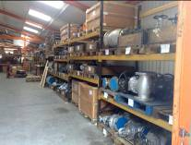
The majority of the aforementioned items are available from stock within our Norfolk premises that include a 9,000 square foot warehouse

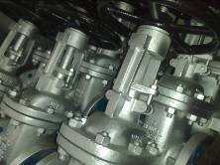
We continue to expand our valve stocks enabling us to offer our clients an ex-stock basis for urgent requirements and reduce delivery where factory lead times are not practical.

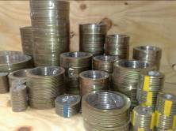
We carry a high level of gasket stock enabling us to deliver quickly for urgent requirements for any requirements where ex-stock is not available most items can be manufactured to order, for some items as quickly as 2 – 3 days.

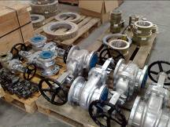
With both valve and gaskets stocks increasing we are able to offer your complete requirements.

Contact Information

Global Oilfield Supplies Ltd
Buntings Lane
Methwold
Norfolk
IP26 4PR

Tel : 0044 (0) 1366 727441
Fax : 0044 (0) 1366 727200

Paul Dargan – paul@globaloilfieldsupplies.co.uk

Robert Gudgion – robert@globaloilfieldsupplies.co.uk

Paul Rose – paul.rose@globaloilfieldsupplies.co.uk

Jamie Preston – jamie@globaloilfieldsupplies.co.uk

How to find us

From London / Cambridge :

Follow the M11 / A11 North until reaching the 5-Ways Roundabout at Barton Mills/Mildenhall.
Take the A1065 through Brandon, heading towards Swaffham, turning left onto the B1112 towards Weeting as you leave the town.
Take the B1112 to Methwold and at the cross roads, turn left onto High Street, following the road.
1 mile later you will see Buntings Lane where we share the industrial centre with Specialised Wheel Services.

From the North :

Go south on the A1(M) leaving onto the A47 towards Peterborough.
Turn off the A47 towards Downham Market, then head south on the A134.
At Stoke Ferry, take the B1112 towards Methwold and at the cross roads, turn right onto High Street, following the road.
1 mile later you will see Buntings Lane where we share the industrial centre with Specialised Wheel Services.

